Yunlu Li

STAT 5170

Homework 8

1.(a)

(b)

(c) i. ii.

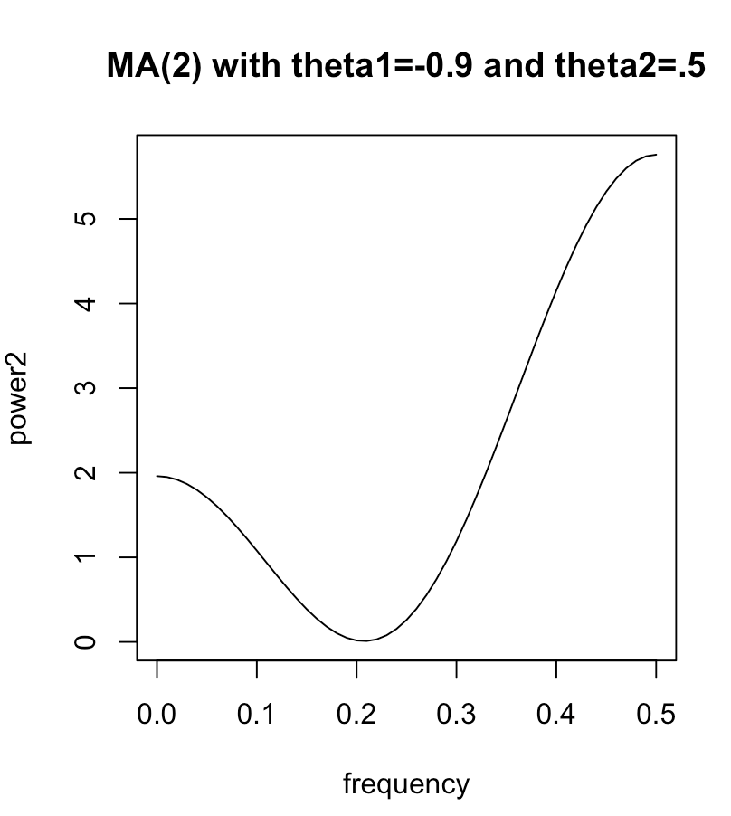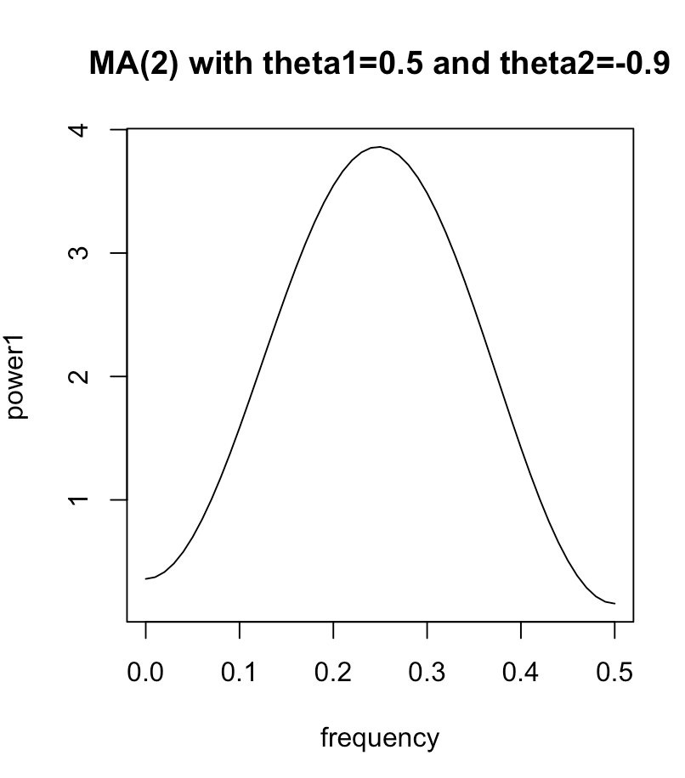

(d) For (i), f(w) increases as w increases and reaches the highest point when w=0.25. Afterwards, f(w) decreases as w increases.

For (ii), decreases as w increases and reaches the lowest point when w=0.25. Afterwards, f(w) increases as w increases.

MA(2) with theta1=-0.9 and theta2=0.5 should result in a faster-changing process, because f(w) is high when w is large.

(e) Due to symmetry of the function and its repeating pattern for frequencies outside the range -1/2 to +1/2, we only need to be concerned with frequencies between 0 and +1/2.

(f) As we can see from two plots below, MA(2) with theta1=-0.9 and theta2=0.5 result in a faster-changing process.

